TASK 7 – Method Overriding and Runtime Polymorphism

Aim
To implement method overriding in the Campus Smart-Parking System using the calculateFee() method and understand the @Override and final keywords.

1. Java Program
class Vehicle {
double calculateFee() {
return 50;
}
@Override
public String toString() {
return "Vehicle";
}
}
class TwoWheeler extends Vehicle {
@Override
double calculateFee() {
return 20;
}
@Override
public String toString() {
return "TwoWheeler";
}
}
class Car extends Vehicle {
@Override
double calculateFee() {
return 50;
}
@Override
public String toString() {
return "Car";
}
}
public class Main {
public static void main(String[] args) {
Vehicle v1 = new TwoWheeler();
Vehicle v2 = new Car();
System.out.println(v1);
System.out.println("Fee: " + v1.calculateFee());
System.out.println(v2);
System.out.println("Fee: " + v2.calculateFee());
}
}
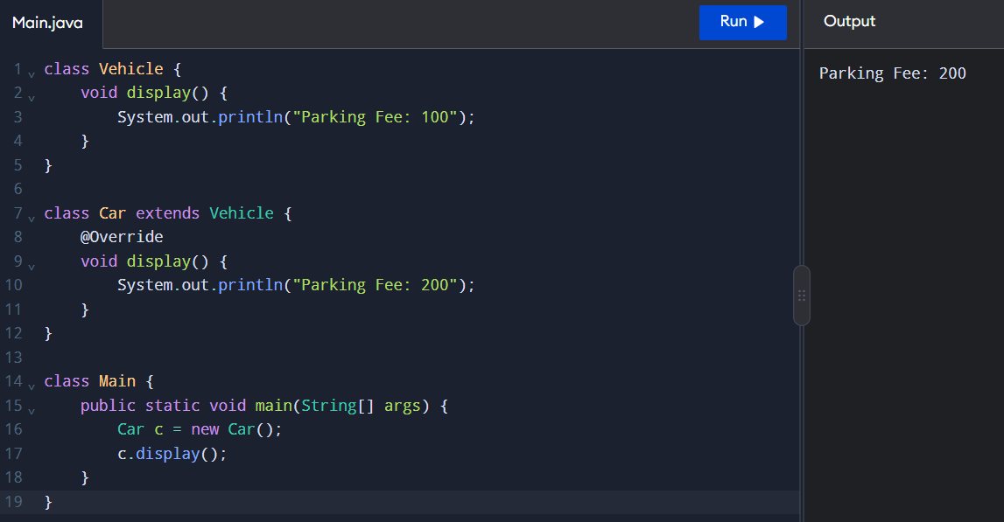

2. Expected Output
TwoWheeler
Fee: 20.0
Car
Fee: 50.0

3. Explanation
- Method overriding: A child class provides its own implementation of a method inherited from its parent class.
- @Override: Indicates that a method is intended to override a parent-class method.
- Runtime polymorphism: The method executed depends on the actual object type at runtime.
- toString(): Returns a readable string representation of an object.
- equals(): Compares objects for logical equality when appropriately overridden.
- hashCode(): Returns a hash value and should be consistent with equals().

4. Use of the final Keyword
The final keyword prevents a method from being overridden by a subclass.
Example:
final void displayParkingRules() {
System.out.println("Follow Parking Rules");
}
A subclass cannot override displayParkingRules().

5. Method Overriding vs Switch Statement

Method Overriding | Switch Statement
Uses inheritance. | Uses conditional selection.
Supports runtime polymorphism. | Selects a case based on a value.
Each vehicle class defines its fee. | Fee logic is grouped in one method.
Easier to extend with new vehicle types. | New types may require modifying the switch.
Supports object-oriented design. | Suitable for simple fixed conditions.

Result
Method overriding was implemented successfully for TwoWheeler and Car. The @Override annotation and toString() method demonstrated runtime polymorphism and object representation in Java.

